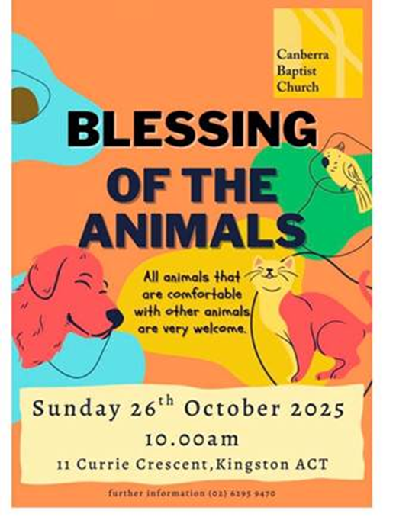

**Dear Friends,**

**This weekend I am heading to the Baptist Monastery in Teesdale, Victoria.** (Yes, that’s right – a Baptist Monastery! (*If you are curious – ask me on my return!)* They are holding a gathering for Victorian Baptists interested in being part of the Open Baptists Association, and Rev David Deal is very kindly preaching for us here at CBC!

But next Sunday I will be back – wild horses couldn’t keep me away – for our ***Blessing of the Animals Service* on Sunday 26th October!**

Today I’ve been reading through old minutes related to the formation of the Open Baptists, but I also found an article I wrote for ***Common Grace*** in 2021, about the *Blessing of the Animals Service*. It explains some of the history, but it also talks about how important this service has become for our congregation, and for our local community.

**Blessing Animals and People at Canberra Baptist Church (October 2021)**

It is now eight years ago that we began holding the *Blessing of the Animals*…

Our first *Blessing of the Animals* was in 2014, and, at that first service, there were the inevitable references made to another service and another female minister – the Vicar of Dibley! At the time, I think, the blessing was viewed as something of a novelty – an event that would engage the families, especially the children, at the second service! *[Pre-Covid CBC had two services; one at 9am and one at 10:30am.]*

Over time, however, as we have continued to bless animals and their owners, and our natural environment, a change has taken place. The *Blessing of the Animals* has shifted from being a novelty, to an important statement that we should make about environmental care, to, finally, a blessing of the world around us that, we have realised, we also need ourselves!

In the first two years, however, the blessing was very much the domain of the second service. I think there was a view that bringing animals into church was not appropriate for a time of worship – certainly not at the first service – and considerable concern was expressed for the carpet! So, we held the first service under the trees in our courtyard, and it was attended by 73 humans, ten dogs, three guinea pigs, two budgies, one cat and one rabbit.

The next year I think bad weather must have threatened, for concessions were made, particularly as we were just about to replace the carpet, and the service was held inside. I said in my sermon that Sunday, *“For the second year in a row here at Canberra Baptist we are doing something a little crazy and bringing animals to church! It is an activity fraught with risk. Will there be snarling or barking? Will there be spitting or hissing? Will there fighting or biting? And – what will the animals be doing while all this is going on?”*

And the conclusion of the sermon was this: *“This morning – this gathering – is a symbol of our desire to love our world as God loves our world; and to commit ourselves to learn… how we can serve and protect our world; and to make the difficult journey… that ensures there is life for this generation and the generations to come. So, this morning, let’s go crazy. Let’s take the risk of blessing our animals and our world!”*

In 2016, however, we were in the middle of a preaching series at this time – animal blessings are usually held near the 4thof October, the feast of St Francis of Assisi – so we didn’t hold a blessing. There were also church meetings taking place which saw me appointed as Team Leader.*[I’ve been team leader for nine years now!]*

But in 2017 we decided to continue blessing the animals. We held the service again outside in the courtyard, but we used the outdoor setting intentionally to reflect on our connections with the natural world. I spoke about St Francis of Assisi preaching to the birds, how he reminded them of God’s incredible creativity and delight in creating them, how God provides for them, and how they should praise God in response. …But the story also indicates that St Francis allowed the birds to minister to him. The encounter ends with the birds inspiring St Francis in his worship.

So, we sat in the courtyard under the trees, in silence, and listened to the sounds around us, asking ourselves, *“What were the birds saying to us? How were they ministering to us?”*

That theme continued the next year, and again in 2019, as we reflected more soberly on *The Global Footprint Network Calculator*, the index measuring how much of the earth’s productive land and sea area we are using to extract resources and dispose of waste. According to this index, since the 1970s human beings have consumed the earth’s resources at a faster rate than they can be replenished. We currently consume as though we had 1.75 earths to live on.

In 2020, however, there was a shift in thinking about the *Blessing of the Animals*. In the weeks leading up to it, people, notably people on the fringes of our community, spoke to me about how much they wanted to be at the service – how they wouldn’t miss it! It was just as we were emerging from that first lockdown, and there had been many changes, brought about by Covid, to how we were worshipping. There was now only one service, but it was a very hybrid service with some people gathered outside, some gathered inside (one person per four square metres) and some over Zoom. We were led by the youth who preached – outside and then inside! And there were the animals; a few cats, one bearded dragon, images sent in by people at home of birds and wildlife they had been observing – far more closely than ever before – during lockdown, and lots and lots of dogs!

The atmosphere was raucous, and it was joyous! It felt as though the earnestness of past years had gone, the sense that we should do this because it was our responsibility to care about caring for creation, as well as the feeling that blessing the animals was a frivolity. After the isolation of lockdown, with all the anxiety of the pandemic, we needed this blessing. We needed to feel connected to the world around us. We needed to acknowledge that we were not isolated or independent of each other and the environment where we live. We weren’t doing this to save the world, but to save ourselves.

Today we hold our blessing all online. *[We were in lockdown in October 2021 and people sent in pictures of their pets and animals in the wild.]* But as I have marvelled at the expression of life and colour and variety and creativity that has come from this congregation this week, my hope is that this service will once again connect us; to each other and to our world and to our God who loves this world, loves this world to wholeness, and blesses every part of it.

**Benediction by Brooke Prentis**

*Creator God, may we see,*

*Your love reflected in our common home,*

*Your joy in the bouncing kangaroo,*

*Your peace in the placid koala,*

*Your patience in the mighty humpback whale,*

*Your kindness in the quizzical Quokka,*

*Your goodness in the Rainbow Lorikeet,*

*Your faith in the ancient Cassowary,*

*Your gentleness in the Leafy Sea Dragon,*

*Your self-control in the Saltwater Crocodile.*

*Now with the fruits of the Spirit, and all of creation,*

*Go in truth, justice, love, and hope. Amen.*

**Please join us Sunday 26 October for our 11th Blessing of the Animals! As the poster says, please only bring animals that are comfortable with other animals! 😊**

***With the fruits of the Spirit and all creation, let us praise God!***

***Belinda***